October 19, 2021
A special meeting of the Board of Fire Commissioners was called to order by Chairman Joseph Zuhoski, Jr. for the purpose of conducting a budget hearing and subsequently a possible vote on the 2022 Fire District operating budget.

Chairman Joseph Zuhoski Jr. opened the hearing at 7 pm with the salute to the flag and introduced the following Board Members who were in attendance: Joseph Zuhoski Jr., Chairman, David Blados, Michael Finnican and Christopher Talbot. Also present were Treasurer, Peter Zwerlein and Secretary, Matthew Martin, Secretary as well as Fire Chief Amos Meringer.

The Secretary then read the Legal Notice of Public Hearing on the proposed budget of the Cutchogue Fire District for 2022 and indicated it had been published in The Suffolk Times September 30, 2021 edition. The Chairman then ordered the Secretary to append a copy of the Legal Notice as published in The Suffolk Times with an Affidavit of Publication be appended to the Minutes of this meeting as Attachment No. 1.

Chairman Zuhoski then stated:

“This is a public hearing regarding the 2022 proposed budget. In accordance with New York State Law the Cutchogue Fire Districts must, prior to the adoption of their budget, hold a public hearing. The purpose of the hearing is to discuss the contents of the budget and to allow members of the public to make comments or ask questions on the budget. The Chairman then announced that any person may be heard in favor of or against the proposed budget or question any item concerning the proposed budget. The Chairman then asked the Fire District Treasurer, Peter Zwerlein to explain the details of the proposed budget. The Treasurer then presented a detailed review of the proposed budget concerning the individual line items and their cost and explained the cost and generally what was involved with each of the items and after the end of the explanation the Treasurer then explained that the total budget after subtracting interest and earnings of $2,500.00 would be $1,956,178.00 which would be raised by taxation. The Treasurer then pointed out that this amount exceeded the allowable required real property tax cap as established by twelve percent (12%) and the Treasurer previously indicated he had certified and reported this increase in a tax cap report which was transmitted to the New York State Comptroller's Office.
Several Board Members had various comments concerning the budget proposal and the Treasurer answered their questions and the Chairman then asked for comments from the public. However, no residents attended the Public Hearing so there were no further comments. The Chairman then ordered the Secretary to attach the proposed budget as presented by the Treasurer to the Minutes of this meeting as Attachment No. 2.
Chairman Zuhoski then stated that since there were no comments from any Board Member and no one from the public attended the meeting, he declared the hearing closed.
After the close of the hearing, the Chairman then stated that since no one had any comments on the budget he asked the Board if they wanted to make any amendments and they indicated there were none the Chairman then stated he thought it was appropriate the Commissioners could consider voting on the budget for the next year and stated that since the Treasurer had reported to the New York State Comptroller's Office and all Board Members were aware that the two percent (2%) tax levy cap would be exceeded and that the increase was twelve percent (12%).
Hearing no further discussions, then Chairman Zuhoski proposed the following resolution:
WHEREAS, the Board of Fire Commissioners of the Cutchogue Fire District must adopt a proposed budget for 2022 and estimate of f und balances in preparation for the annual Fire District budget hearing and did so in preparation for the budget hearing; and
WHEREAS, the Board of Fire Commissioners of the Cutchogue Fire District held the annual Fire District budget hearing on notice to the public on October 19, 2021; and
WHEREAS, the Board has considered the proposed budget and there were no comments received from the public on the proposed budget on October 19, 2021 at said budget hearing; and
WHEREAS, the Board has determined that the financial needs of the Cutchogue Fire District and Fire Department for fiscal year 2022 cannot be supported by a budget that would comply with the real property tax cap established pursuant to Section 3-c of the General Municipal Law as the proposed budget for 2022 calls for a real property tax levy that will exceed the real property tax cap permitting only a two percent (2%) increase in said tax levy; and
WHEREAS, Section 3-c of the General Municipal Law provides as follows:
A local government may adopt a budget that requires a tax levy that is greater than the tax levy limit for the coming fiscal year, not including any levy necessary to support the expenditures pursuant to subparagraphs (i) through (iv) of paragraph g of subdivision two of this section, only if the governing body of such local government first enacts, by a vote of sixty percent of the total voting power of such body, a local law to override such limit for such coming fiscal year only, or in the case of a district or fire district, a resolution approved by a vote sixty percent of the total voting power of such body's override such limit for such coming fiscal year only.
NOW, THEREFORE, BE IT RESOLVED, that the Board of Fire Commissioners hereby approves a determination to override the real property tax cap for the 2022 budget only in order to permit an annual real property tax levy that will exceed the real property tax cap permitting only a two percent (2%) increase in said tax levy and result in a final annual Fire District budget in the amount of $1,956,178.00; and
The adoption of the foregoing resolution was duly put to a vote and upon roll call the vote was as follows:
Chairman Joseph J. Zuhoski, Jr. Aye Commissioner David Blados Aye Commissioner Michael Finnican Aye Commissioner Christopher Talbot Aye
The resolution was thereupon duly declared to have been adopted.
Dated: October 19, 2022

Chairman Zuhoski then proposed the following resolution:
WHEREAS, the Board of Fire Commissioners of the Cutchogue Fire District must adopt a proposed budget for 2022 and estimate of fund balances in preparation for the annual Fire District budget hearing and did so in preparation for the budget hearing; and
WHEREAS, the Board of Fire Commissioners of the Cutchogue Fire District held the annual Fire District budget hearing on notice to the public on October 19, 2021; and
WHEREAS, the Board has considered the proposed budget and no comments were received on the proposed budget on October 19, 2021 at said budget hearing; and
WHEREAS, the Board has determined that the financial needs of the Fire District and Fire Department for fiscal year 2022 cannot be supported by a budget that would comply with the real property tax cap established pursuant to Section 3-c of the General Municipal Law as the proposed budget for 2022 calls for a real property tax cap levy that will exceed the real property tax cap permitting only a two percent (2%) increase in said tax levy; and
WHEREAS, Section 3-g of the General Municipal Law provides as follows:
A local government may adopt a budget that requires a tax levy that is greater than the tax levy limit for the coming year, not including any levy necessary to support the expenditures pursuant to subparagraphs (i) through (iv) of paragraph g of subdivision two of this section, only if the governing body of such local government first enacts by a vote of sixty percent of the total voting power of such body, a local law to override such limit for such coming fiscal year only, or in the case of a district or fire district, a resolution, approved by a vote of sixty percent of the total voting power of such body, to override such limit for such coming fiscal year only.
WHEREAS, previously at this meeting the Board of Fire Commissioners passed a resolution to override the real property tax cap for 2022 budget.
NOW, THEREFORE, BE IT RESOLVED, that the Board of Fire Commissioners hereby approves the final budget for the Cutchogue Fire District for 2022 attached hereto and made a part hereof in the amount of $1,956,178.00.
The adoption of the foregoing resolution was duly put to a vote and upon roll call the vote was as follows:
Chairman Joseph J. Zuhoski, Jr. Aye Commissioner David Blados Aye Commissioner Michael Finnican Aye Commissioner Christopher Talbot Aye
The resolution was thereupon duly declared to have been adopted.
Dated: October 19, 2022
Chairman Zuhoski then seeing there was any other business to be attended to at this special meeting and since there were none, called for an adjournment, which was so moved by Comr. Blados, seconded by Comr. Finnican, motion carried unanimously. The meeting was adjourned at 7:40 pm.
Matthew J. Martin
Fire District Secretary

Attachment No. 2—2022 Budget
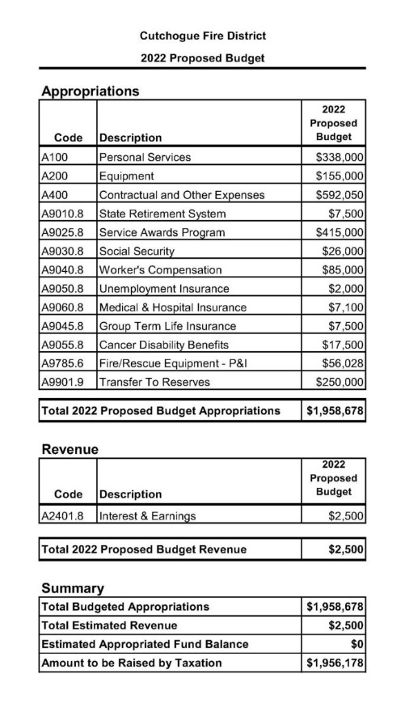

Attachment No. 1-- Legal Notice of Hearing.

To: Suffolk Times Newspapers
Mattituck, NY
September 28, 2021

To: Suffolk Times Newspapers Mattituck, NY Legal Notice of Public Hearing on the Budget Cutchogue Fire District.
NOTICE IS HEREBY GIVEN that the 2022 Proposed Budget of the Cutchogue Fire District of the Town of Southold, State of New York, will be presented to the Board of Fire Commissioners of the Cutchogue Fire District, for its consideration.
A PUBLIC HEARING will be held at 7:00 p.m. at the Cutchogue Fire House, 260 New Suffolk Rd., Cutchogue, New York 11935, in the Town of Southold, State of New York on the 19th day of October 2021. The purpose of the public hearing is to allow any person to be heard in favor of or against the proposed budget as it is submitted, or for or against any item or items contained in the proposed budget, and hearing all persons interested in the subject concerning same. That a copy of the proposed budget is available at the Office of the Town Clerk of the Town of Southold at 260 New Suffolk Rd, Cutchogue, NY 11935 and Fire District Secretary at 260 New Suffolk Rd, Cutchogue, NY 11935 where it may be inspected by any interested person during office hours 9am to 5pm. The Budget is also posted on the Cutchogue Fire Dept. web site www.cutchoguefiredept.org under the Fire District Menu. Dated: September 24, 2021

Board of Fire Commissioners
Matthew J. Martin, Secretary Cutchogue Fire District
Publish in Legal by September 30th, 2021 Certified.

